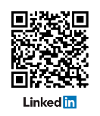
Student Name-Surname
Adress • phone • e-mail

EDUCATION

- Date
- Date
- Date

EXPERIENCE

CERTIFICATIONS AND SKILLS

Laboratory Techniques :

Programming :

Languages : English (native), French (fluent), Spanish (fluent), German (basic), Portuguese (basic)

LEADERSHIP & SERVICE

